RED RIBBON WEEK  10/26/2020-10/30/2020 | 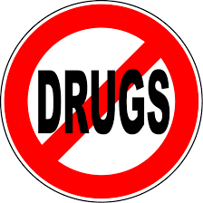
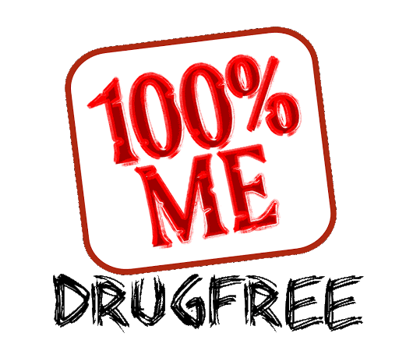 | 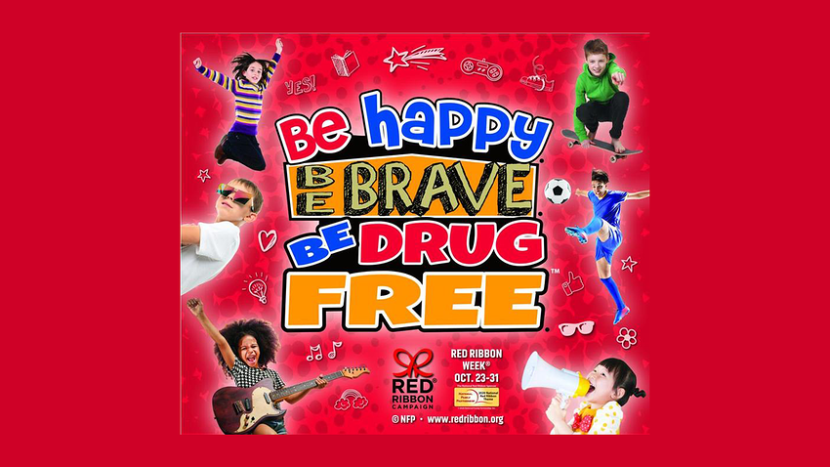

  - DRESS UP THEME DAYS:
    - Monday- Wear red to kick off Red Ribbon Week
    - Tuesday- Happy Emoji Day (Dress up like a happy emoji)
    - Wednesday- Be Brave (Dress patriotic)
    - Thursday- Hats off to a drug free life (Wear hats)
    - Friday- You have the power to say NO (Dress like a superhero)

