2018-2019 Thomas E. Weightman Middle School
6th Grade Activities Expectations

Student name: _________________________ Team:________________ ELA Teacher:__________________

TEWMS 6th grade students wanting to participate in the End-of-Year Activities are expected to display a high caliber of well-mannered behavior at all times. In order to participate, academic and behavioral expectations have been established.

Any 6th grader who meets the following academic or behavioral expectations will be eligible to participate:

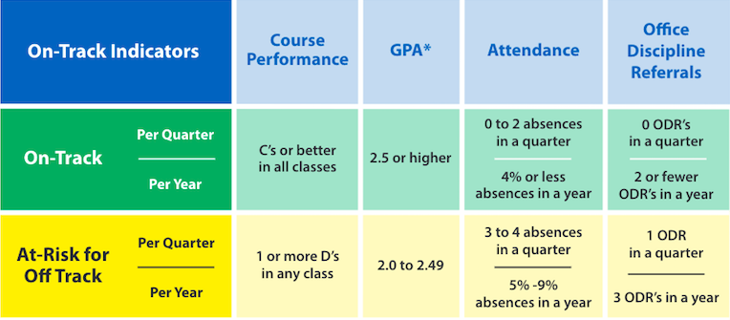

Check-ins will take place each quarter with any students who DO NOT meet the above criteria. A final check will take place 4 weeks before the event and a final determination made regarding eligibility.

If a student loses their eligibility in the second, third, or fourth quarter due to behavior based infractions, points may be earned to regain eligibility. A total of 50 points per quarter must be earned. Way to earn points are as follows:

Attendance: If you miss two days or less per quarter during second, third, or fourth quarter, you will earn 25 points for each quarter.

Volunteering: For volunteering at Special Olympics, PTSA, sporting events etc., you will earn 25 points. You may volunteer in the community with approval and with documentation. (A maximum of four events can be counted towards points).

Other: Attending ONE session of Opportunity Hall will earn you 25 points. Attending TWO academic lunch sessions with Ms. Eads will earn you 25 points. Monday & Friday’s only!

I understand the behavior expectations for 6th grade activities. I also understand that I may earn points in order to regain eligibility if I lose my privilege during the second, third, or fourth quarter. I also understand that my points must be documented and signed off by a supervising teacher if I am earning points through volunteering. I acknowledge that I am responsible for my behavior.

Student signature: ________________________________________ Date: ____________________

We have read and understand the requirements as set forth for ___________________(student’s name) to be eligible to participate in the events planned for the 6th grade students at TEWMS. We also understand that these are school-sponsored activities and the Code of Student Conduct will be strictly enforced. We also understand that if we pay for the field trip, but then my child does not attend due to disciplinary or academic reasons, the amount paid toward the field trip will be non-refundable.

Parent Signature: _____________________________________ Date: _____________________

